RESOLUTION NO.__________

RE: CERTIFICATE OF APPROPRIATENESS UNDER THE
PROVISIONS OF THE ACT OF THE PENNSYLVANIA
LEGISLATURE 1961, JUNE 13, P.L. 282 (53
SECTION 8004) AND BETHLEHEM ORDINANCE NO.
3952 AS AMENDED.

WHEREAS, it is proposed to re-roof the main house at 238 E.
Market Street.

NOW, THEREFORE, BE IT RESOLVED by the Council of the City of Bethlehem that a Certificate of Appropriateness is hereby granted for the proposal.

Sponsored by: (s)

(s)

ADOPTED BY COUNCIL THIS DAY OF

(s)
President of Council

ATTEST:

(s)
City Clerk

HISTORICAL & ARCHITECTURAL REVIEW BOARD

The applicant is proposing to re-roof the main house at 238 E.
Market Street.
APPLICATION #4:

Dr. & Sir LLC
817 S. Second St.
Bethlehem, PA 18018

OWNER:

__________________________________________________________________________

The Board upon motion by Marsha Fritz and seconded by Connie Glagola adopted the proposal that City Council issue a Certificate of Appropriateness for the following:

- Replace roof with new GAF Slateline Shingles in Antique slate color.

- Valley flashing and chimney flashing to be exposed copper or lead coated copper.

- Drip edge to be aluminum painted.

4. The motion was unanimously approved.
__________________________________________________________________________

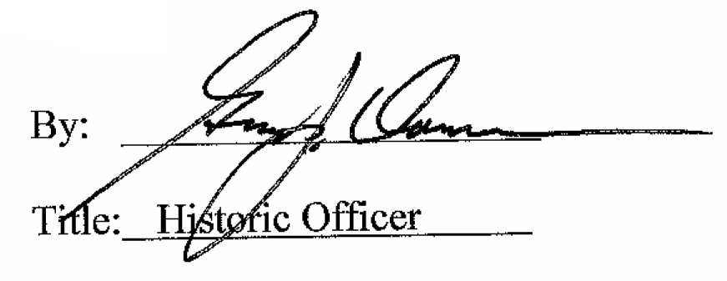

Date of Meeting: January 4, 2017

